**GIT**

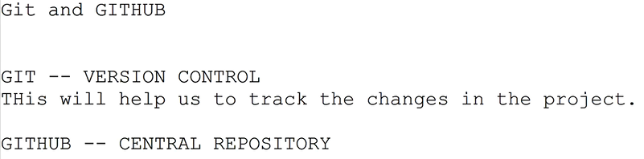

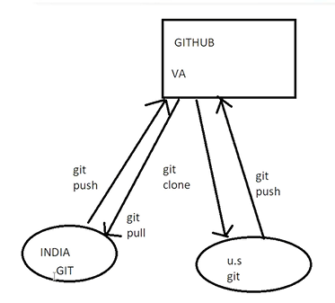

When we install Gitbash then git is also installed (Window)

*git –version

To check the version of the git

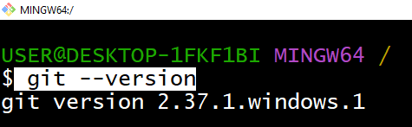

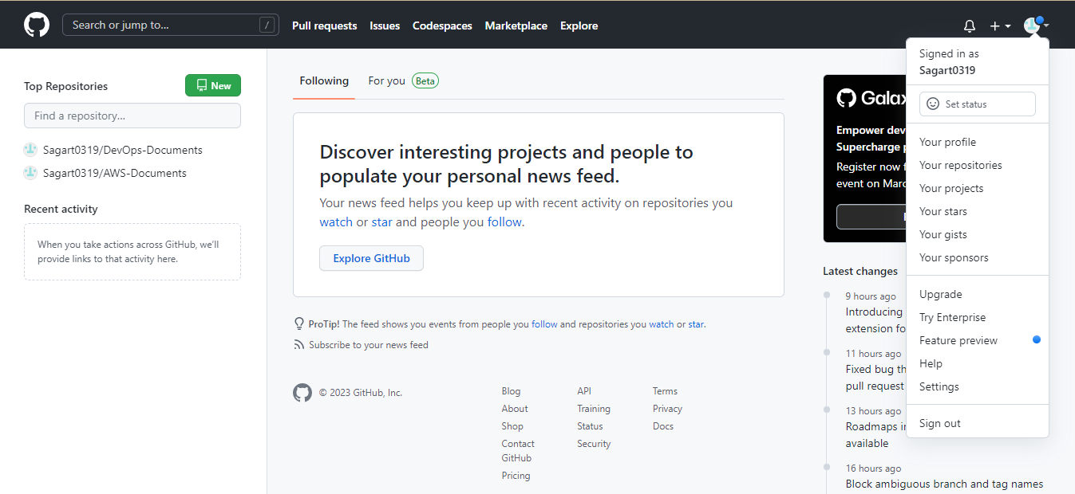

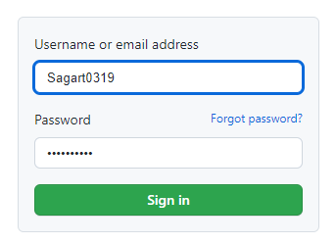

Git like similar tools

**SVN (Subversion), Bitbucket, Perforce, and Mercurial**

* Azure DevOps Server.
* Helix Core.
* AWS CodeCommit.
* Subversion.
* Rational ClearCase.
* Plastic SCM.
* Mercurial.
* Micro Focus AccuRev.
* 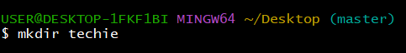
* 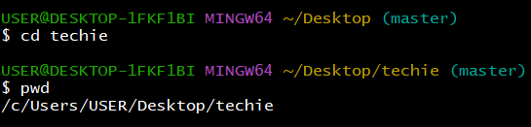

Techie folder is the project

* 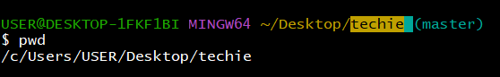
* Before git initialise (git init) / shown below like this

*git status

* Git status is used for track the changes of the files
* 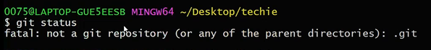

*ls –al

To check the hidden files

* 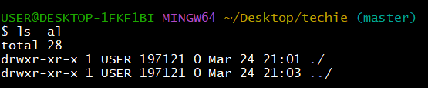

*git init

* When we do git init (intialise) then default branch master will create
* 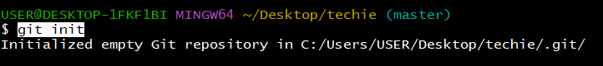
* By using .git folder all project details will be tracked
* 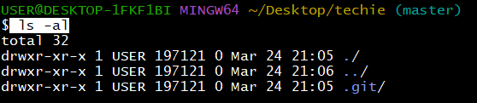
* 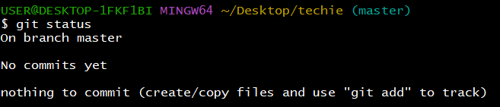
* 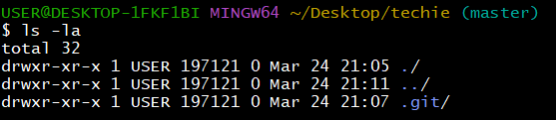
* 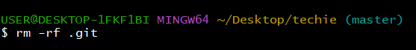
* If we delete the .git folder then default master branch will be delete
* Without .git folder tracking will not be done in the project

*git status

* 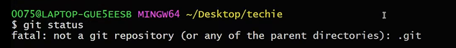
* 3 files
* 4 folders

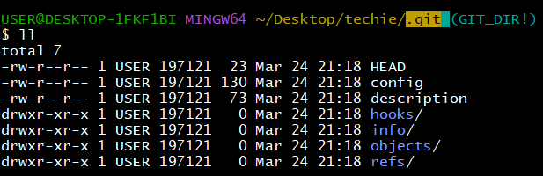

This is referring to the master branch

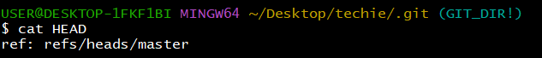

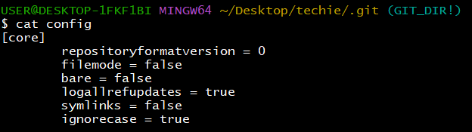

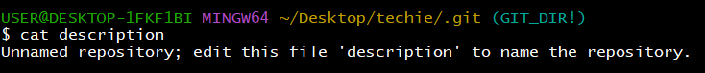

This all kind of scripts / this scripts are protecting our branches

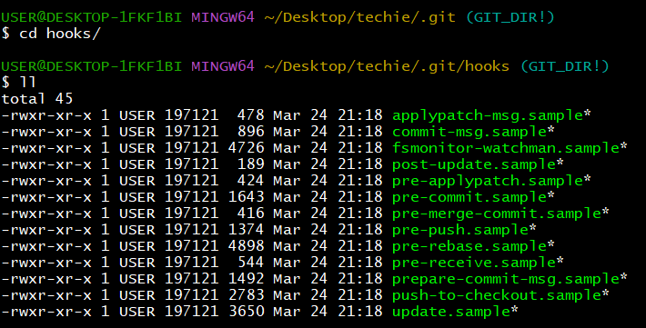

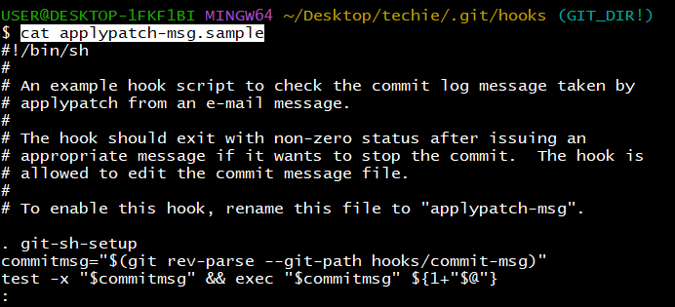

This pre-push script is useful for prevent the unknown person push’s

To avoid Un nessary content



Don’t delete .git foler

Whatever we have changed in files and project / it is identified with usernames

*git config –list

We can check the complete configuration list / Username / Password

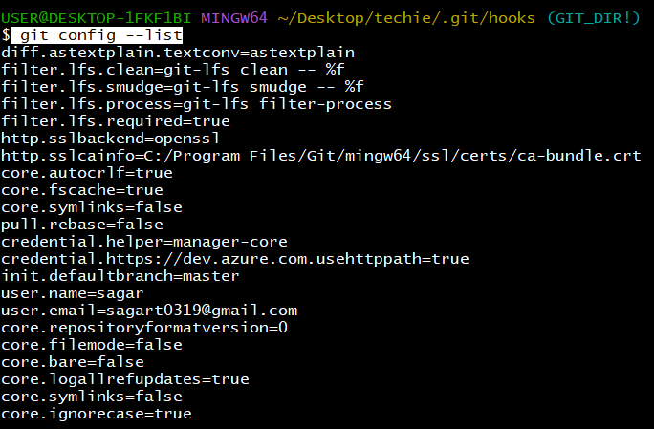

*git config --global user.name "sagarthandra”

To change the user name in the global configuration



I have chaned the username sagar to sagarthandra

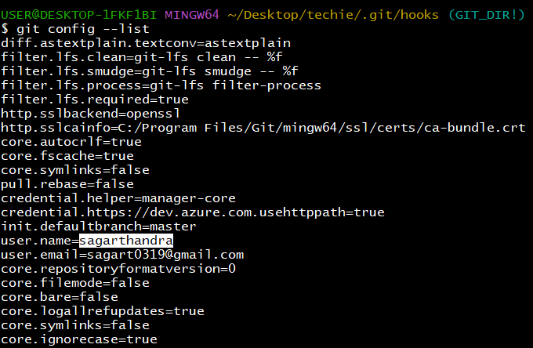

git config --global user.email "thandrasagar319@gmail.com"

I have changed the email in config file

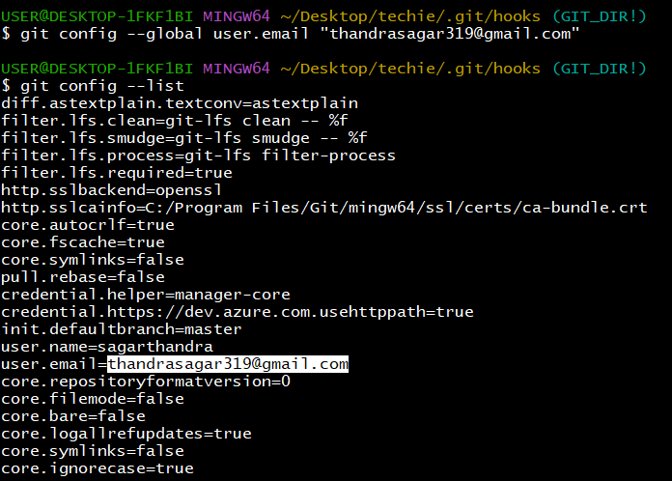

I have create file touch

Checked the status of the file

It is in untracked stage

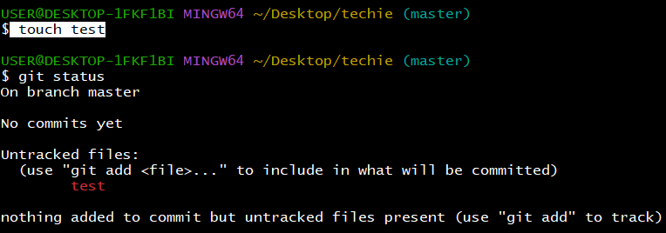

*Git add test

Test file added into tracking / from untracking to tracking changed

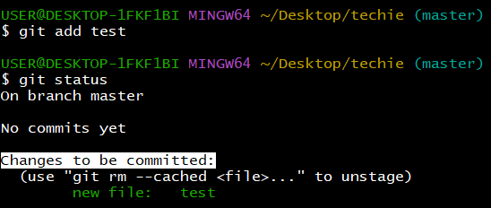

Then we need to do the commit / then only we can push the file to central repository

*git commit -m "created new called test"

*-m means message / message should be relevant / it should be understand everyone in the project

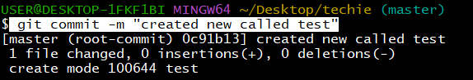

*0c91b13

This is the commit id / each commit will generate the unique id /

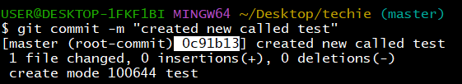

We have committed the files before then we don’t have any files to commit

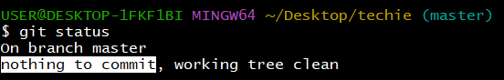

Created new files a,b

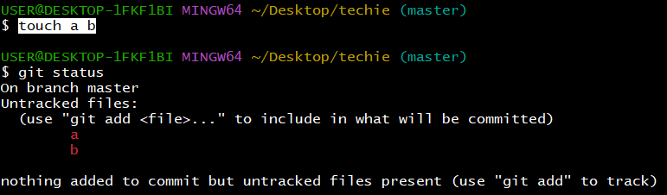

*git add . (by using . dot we can add all files once)

If we want add files for tracking at once / we can use this command

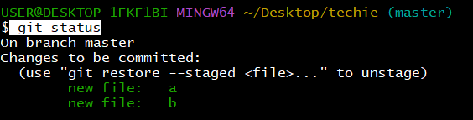

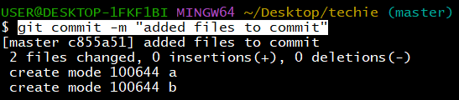

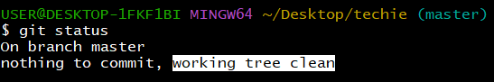

I want to push this files to centralised repository / and store there

*we have not configured the destination

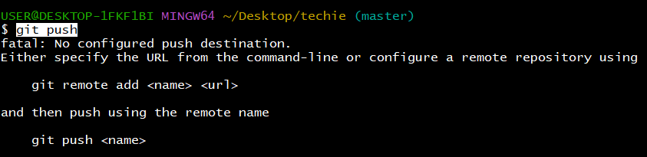

We want to create one repository in git hub / to push this files

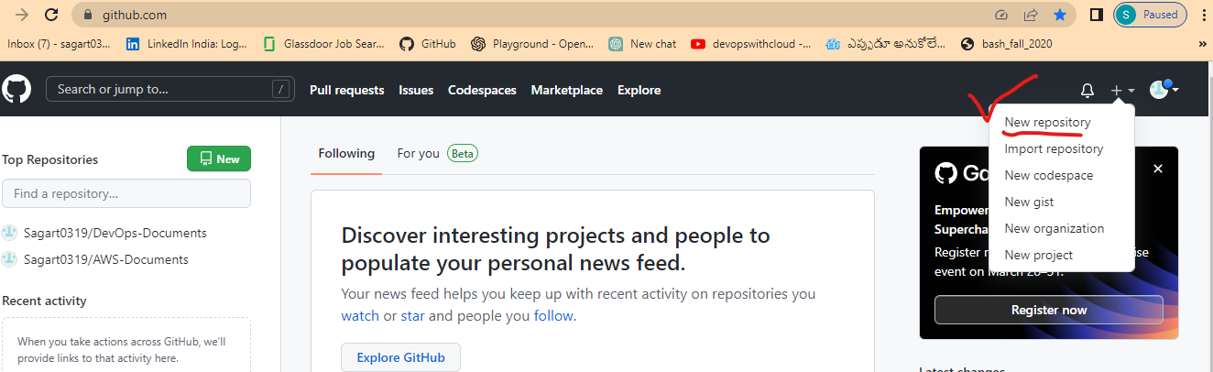

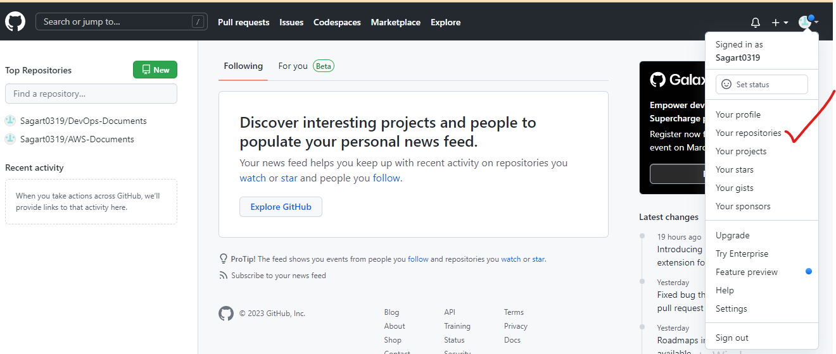

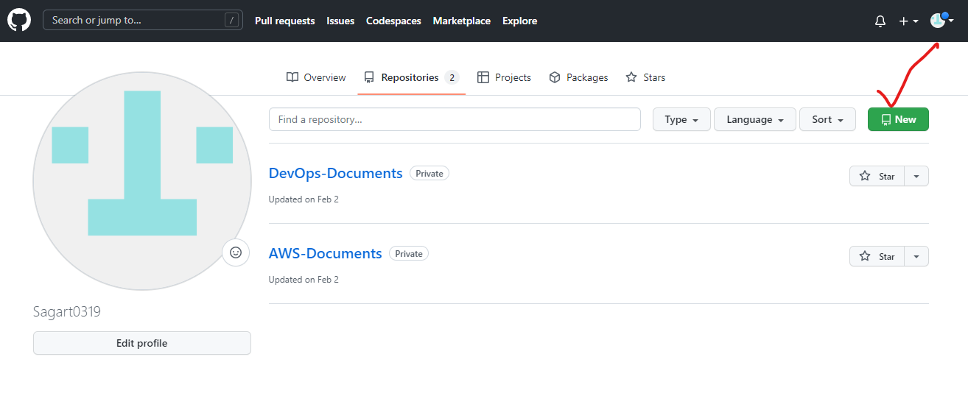

To create repository fill the below details

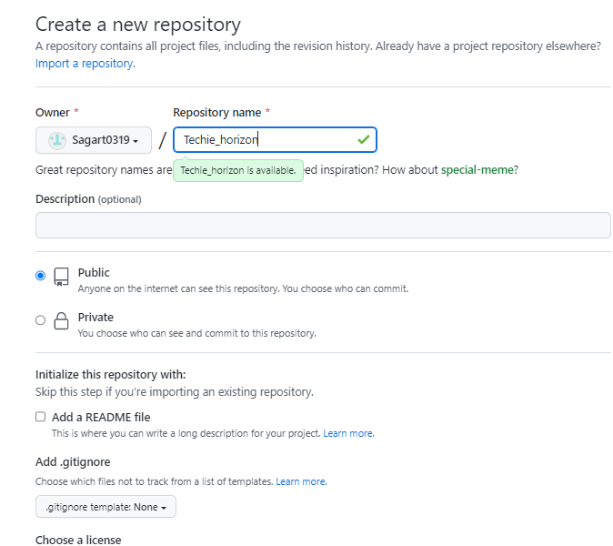

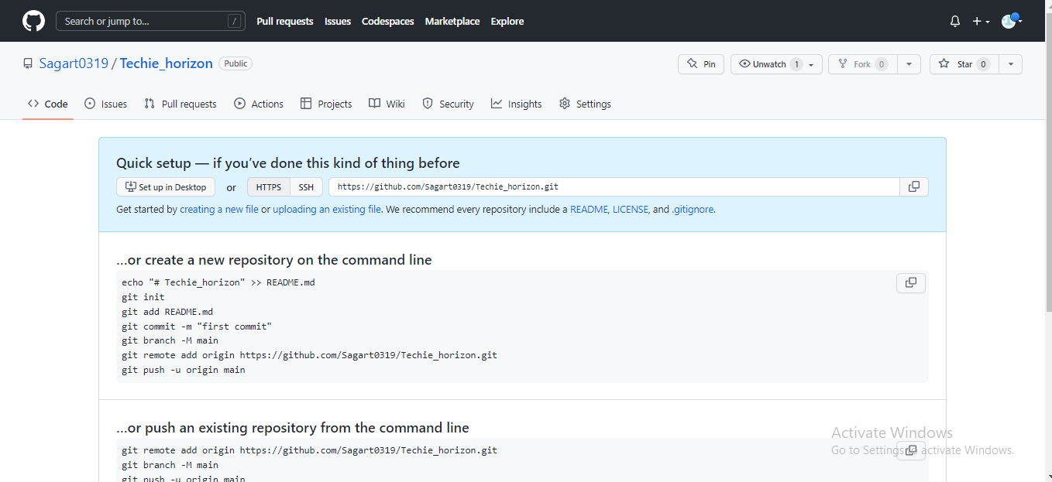

*git remote –v

It will show the remote repositories (added)



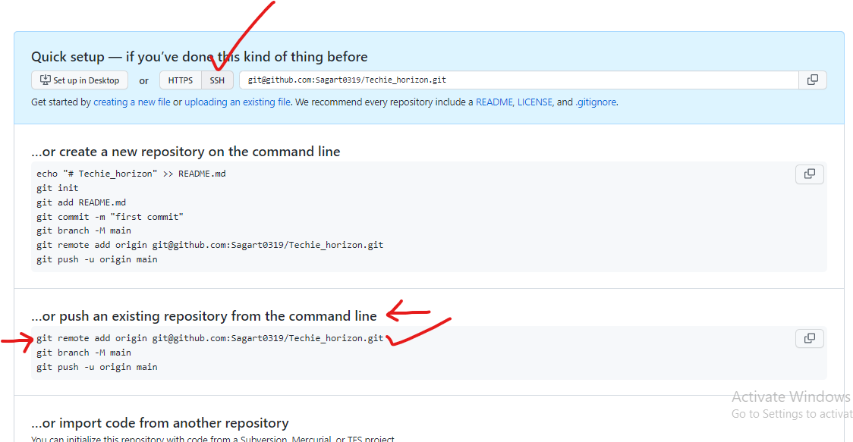

Added git remote repository

*git remote add origin git@github.com:Sagart0319/Techie_horizon.git



*git remote –v

To check the remote repositories added list

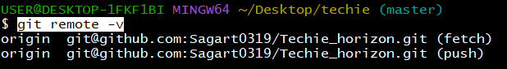

*cat .git/config

After adding the remote files /added git hub connection with git / details added in .git config file (orgin details configured)

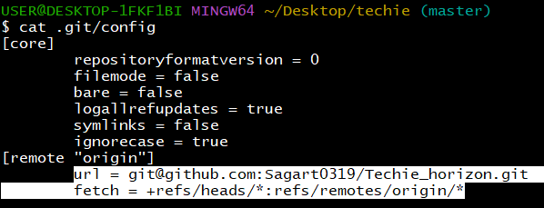

*git push -u origin master

We can only use (git push) / but –u = is more segregated / origin= path / master = we are pushing to the master branch

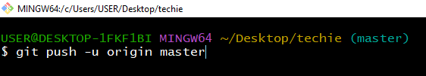

While pushing the branch to the git hub repository / I got error below like this

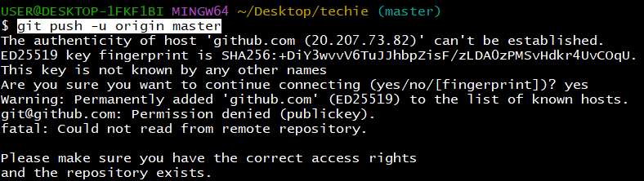

Then I created ssh-keygen in git bash / also pasted in github

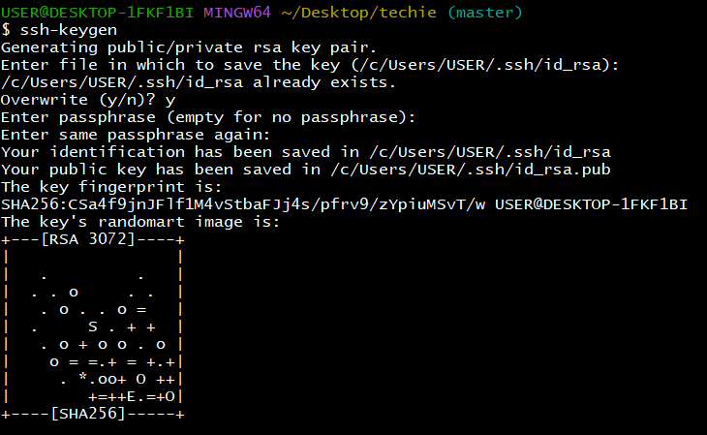

Then I pasted this ssh-keygen in git hub

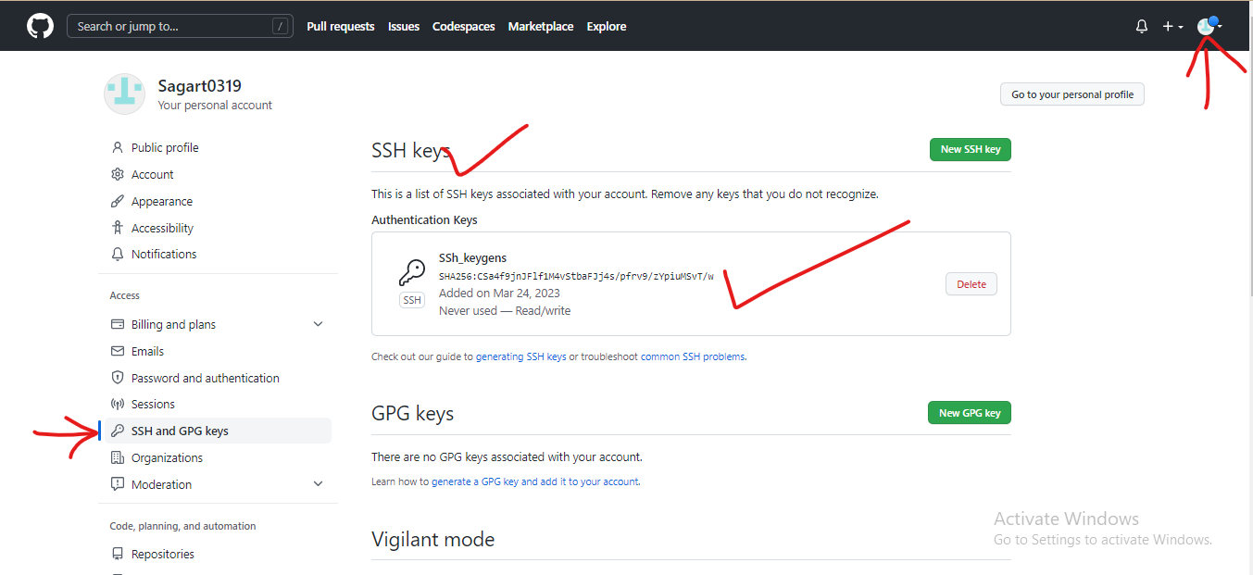

*Still issue have not resolved

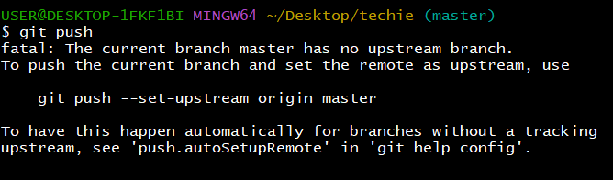

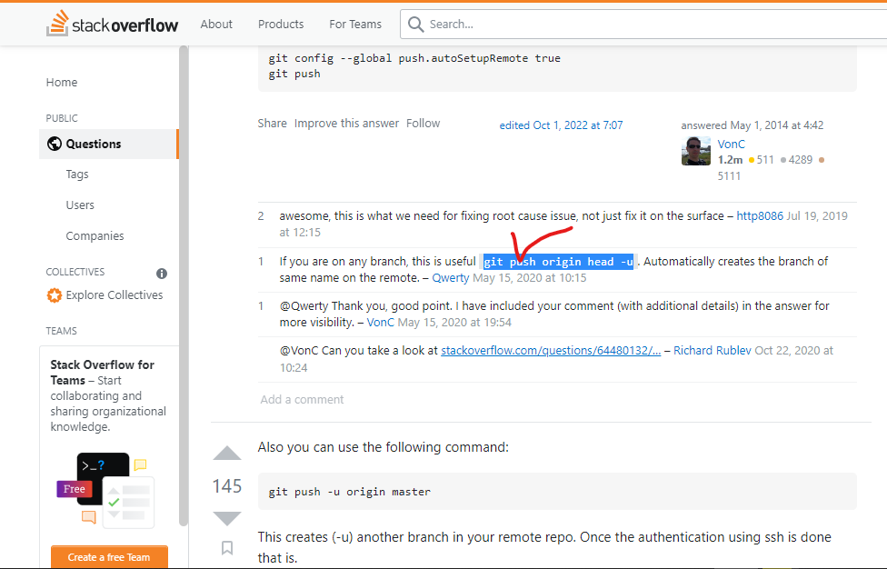

*git push origin head -u

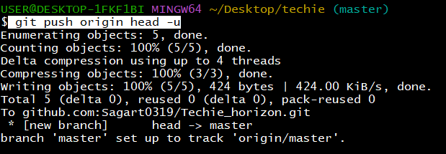

After refreshing we can able to see files pushed to the github

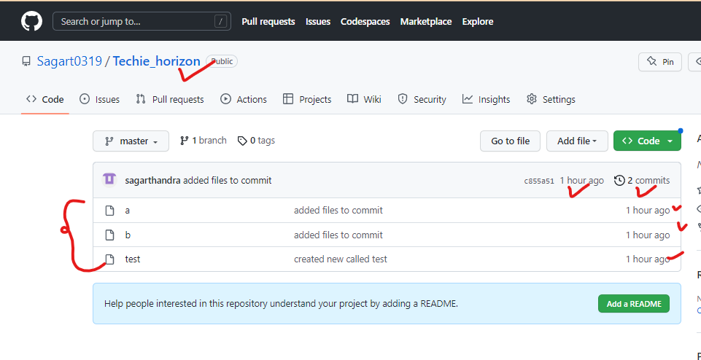

We can able see the commits / commit timings

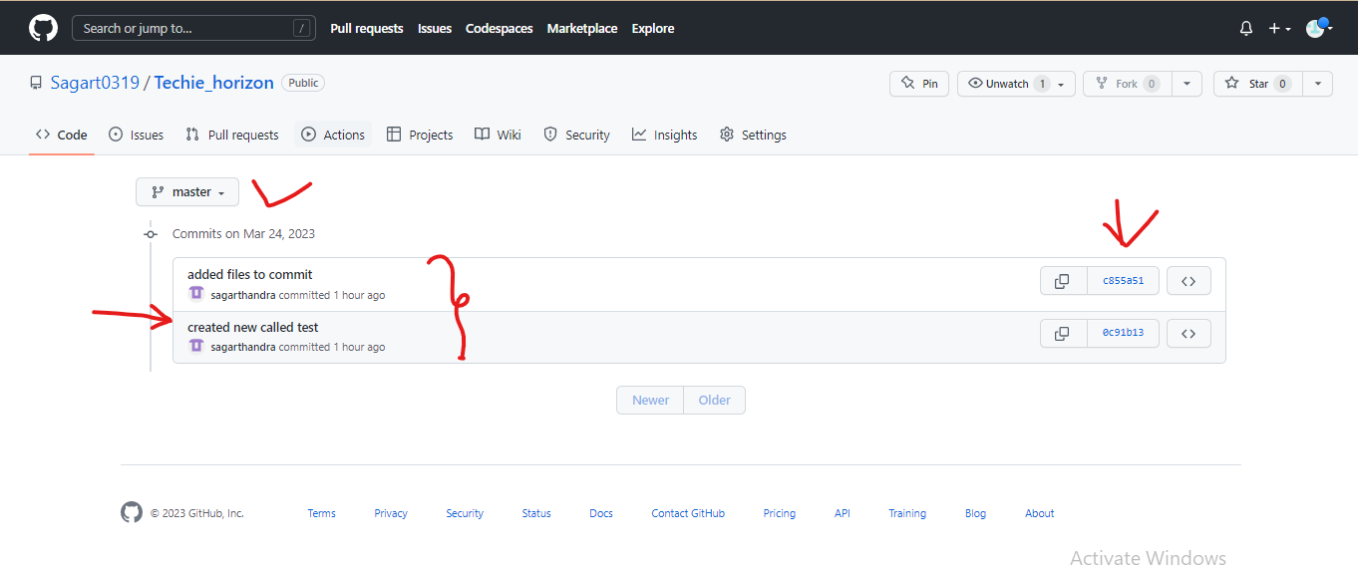

We can able to see the commit details clearly / Commit msg also we can see

*we can use the starting commit 5 letters

*git log -1

We can check latest last commit details

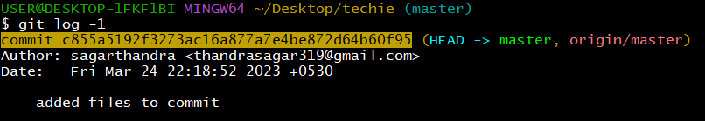

Last latest commits

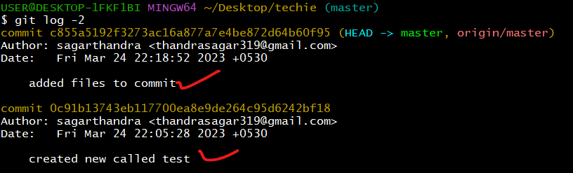

We can also create files in GitHub GUI

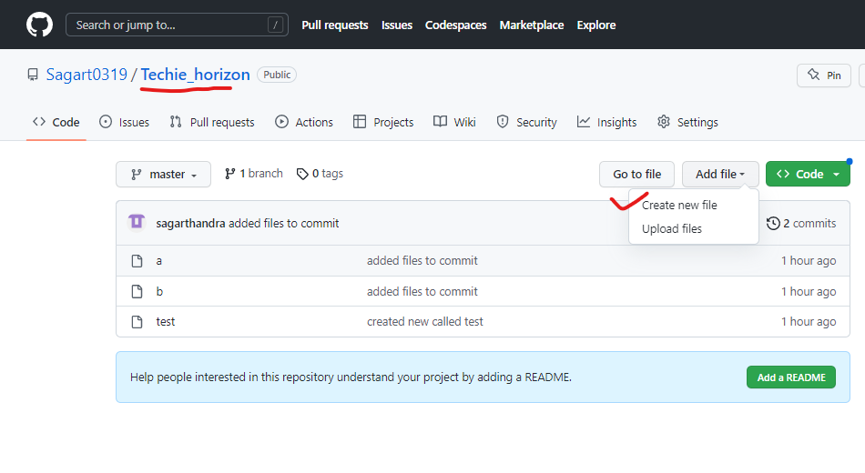

After creating the file in Gui / we have to add the message / then create file

*We have to mention the file name also

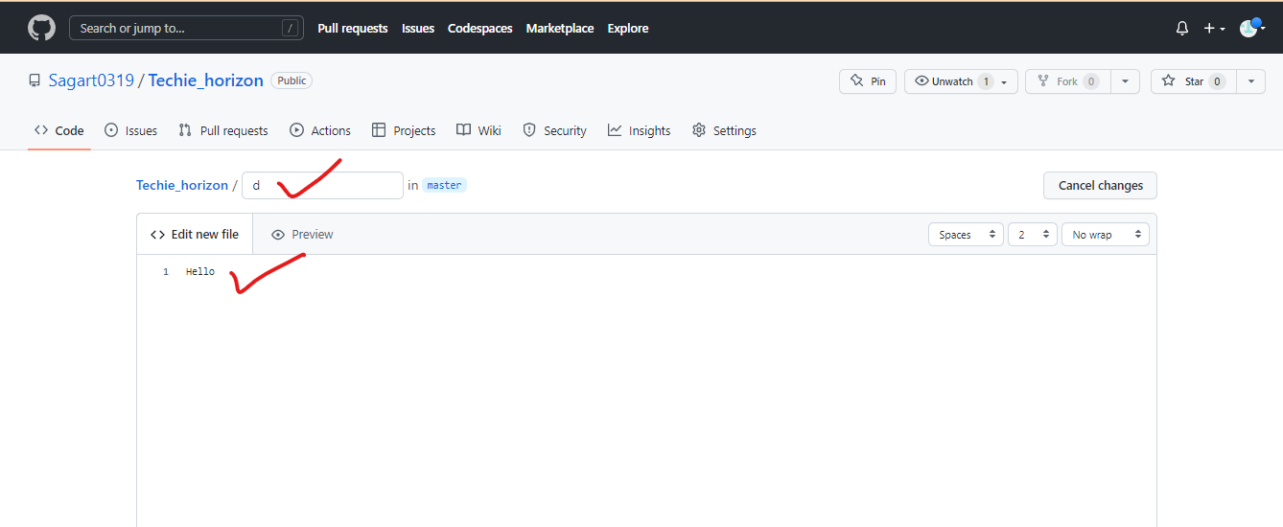

File “d” is created / it is created in Github by using GUI options/ this new file is not updated in git bash

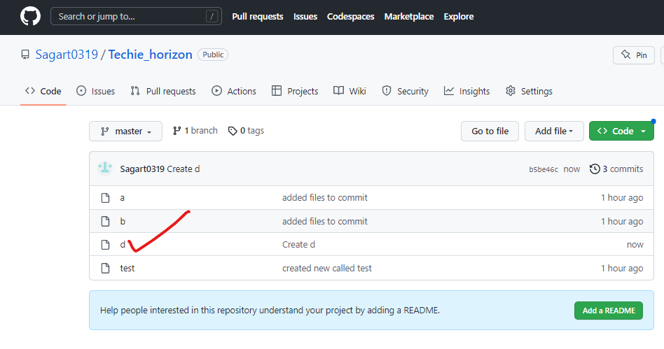

I have checked the local files / new github file not updated in locally

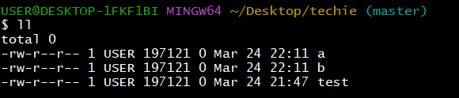

*New file created in git bash “”Zebra”



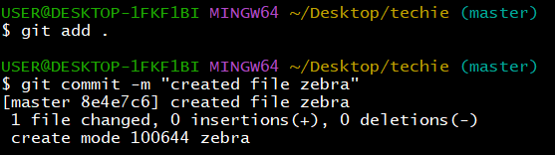

While pushing the file getting error / because new file created in github before this executing / github file is not updated in locally / that’s y we are getting error

*Use git pull (before executing this command)

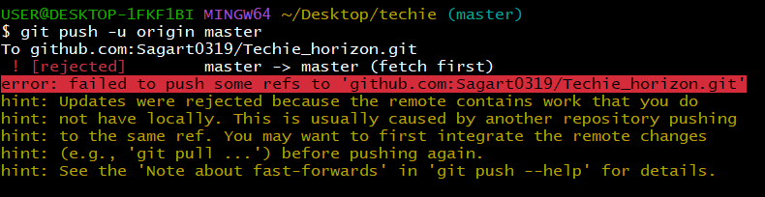

After using the git pull command / github file is updated locally (file name “d”)

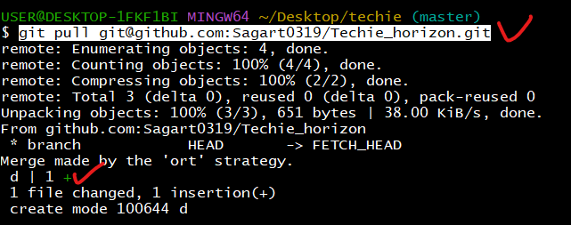

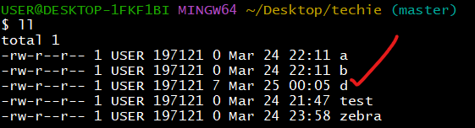

Git push has done / because remote and local both are synconarised successfully

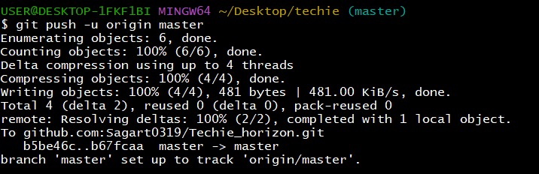

Whatever we have done the changes in local we don’t get any problem / but what we have done changes centrally we need to update in local